TEACHER MASTER EDITION • COMPLETE SOLUTIONS & AP RUBRICS
2D Projectile Motion: Video Tracking & Kinematics Analysis
AP Physics C: Mechanics • Laboratory Solution Manual & Scoring Rubric • Lab-ove and Beyond

Course: AP Physics C (Mechanics) | Period / Block: ________ | Class Duration: 42 Minutes
Instructor: MR. F. / AP Physics Dept | Master Solution & Rubric Key | Curriculum Unit: 1.3 (2D Projectiles)

Instructor Overview: Complete worked solutions, scoring rubrics, and AP exam alignment for the 42-minute core lab and 8-point calculus extension. Values reflect tracking the classic parabolic motion video.
■ AP PHYSICS C: UNIFORMLY ACCELERATED MOTION (UAM) REFERENCE FORMULAS
(1) $v = v_{0} + a·t$ (3) $v^{2} = v_{0}^{2} + 2a·Δx$
(2) $Δx = v_{0}·t + \frac{1}{2}a·t²$ (4) $Δx = (\frac{v_{0} + v}{2})·t$
* Note: Apply component-wise with ax = 0 (horizontal) and ay = -g (vertical). No further equations are provided.

Pacing Clock & Instructional Plan
The 42-minute period covers Steps 1-5 and Sections 2-3 (17 points). Section 4 is an 8-point calculus extension for outside study.
Class Time | Lab Phase | What You Actually Do | Pts
0:00 - 0:04 (4m) | 1. Set Up & Calibrate | Load 'FizziQ: Parabolic Motion (Classic Lab)' (30.0 FPS, Δt = 0.0333 s). Ruler tool: click both ends of the 1.00 m rod and enter 1.00 m. Origin tool: click the ball at Frame 0, then set +Y up and +X downrange. | —
0:04 - 0:14 (10m) | 2. Track & Record | Autotrack (⚡) the ball across the 25 tracked frames, then export the CSV. Copy x, y, vx, vy and v into the 5-milestone data table. | 1
0:14 - 0:25 (11m) | 3. Physical Measurements | Section 2 - Q2.1 launch speed, angle and vector (3 pts). Q2.2 derive & predict apex/range, then measure and verify (3 pts). Q2.3 mid-ascent vectors, direction angle and a∥ / a⊥ (3 pts). | 9
0:25 - 0:35 (10m) | 4. Graphs & Curve Fits | Section 3 - x(t) linear fit and ax (2 pts). y(t) quadratic fit, g_exp and % error (3 pts). vy(t) fit comparison and the y(x) trajectory shape (2 pts). | 7
0:35 - 0:42 (7m) | 5. Check & Submit | Verify every answer carries SI units and the correct sign. Compare your fitted values with the app readouts. Staple the handout and submit. | —
42 minutes | CORE TOTAL | Required work that is graded during the period. | 17
+25 min outside class (25m) | 6. Optional Extension | Section 4 - AP Physics C calculus challenges: C4.1 trajectory derivation (3 pts), C4.2 position integration & impact velocity vector (3 pts), C4.3 minimum-speed extremum (2 pts). Not required to finish the 42-minute lab. | 8

■ PERIOD MANAGEMENT GUIDE
• Core Lab: Keep students moving through Section 2 by 0:14 and Section 3 by 0:25.
• Autotracker: Emphasize setting the calibration rod (1.00 m) before placing origin.
• Derivation First: Ensure students derive formulas in Question 2.2 before looking at data table.
• Calculators: Scientific or graphing calculator required for arctan and regression comparisons.

1. Experimental Setup & Video Tracking Protocol
■ APP SETUP VERIFICATION KEY
1. Video: 'FizziQ: Parabolic Motion (Classic Lab)' — 30.0 FPS (Δt = 0.0333 s per frame).
2. Scale Calibration: 1.00 m rod on left apparatus pillar.
3. Coordinate Origin: Projectile release point at Frame 0: (x0, y0) = (0.000, 0.000) m.
4. Tracking: 25 tracked points (Frames 0 to 24). Total physical duration: 0.800 s.

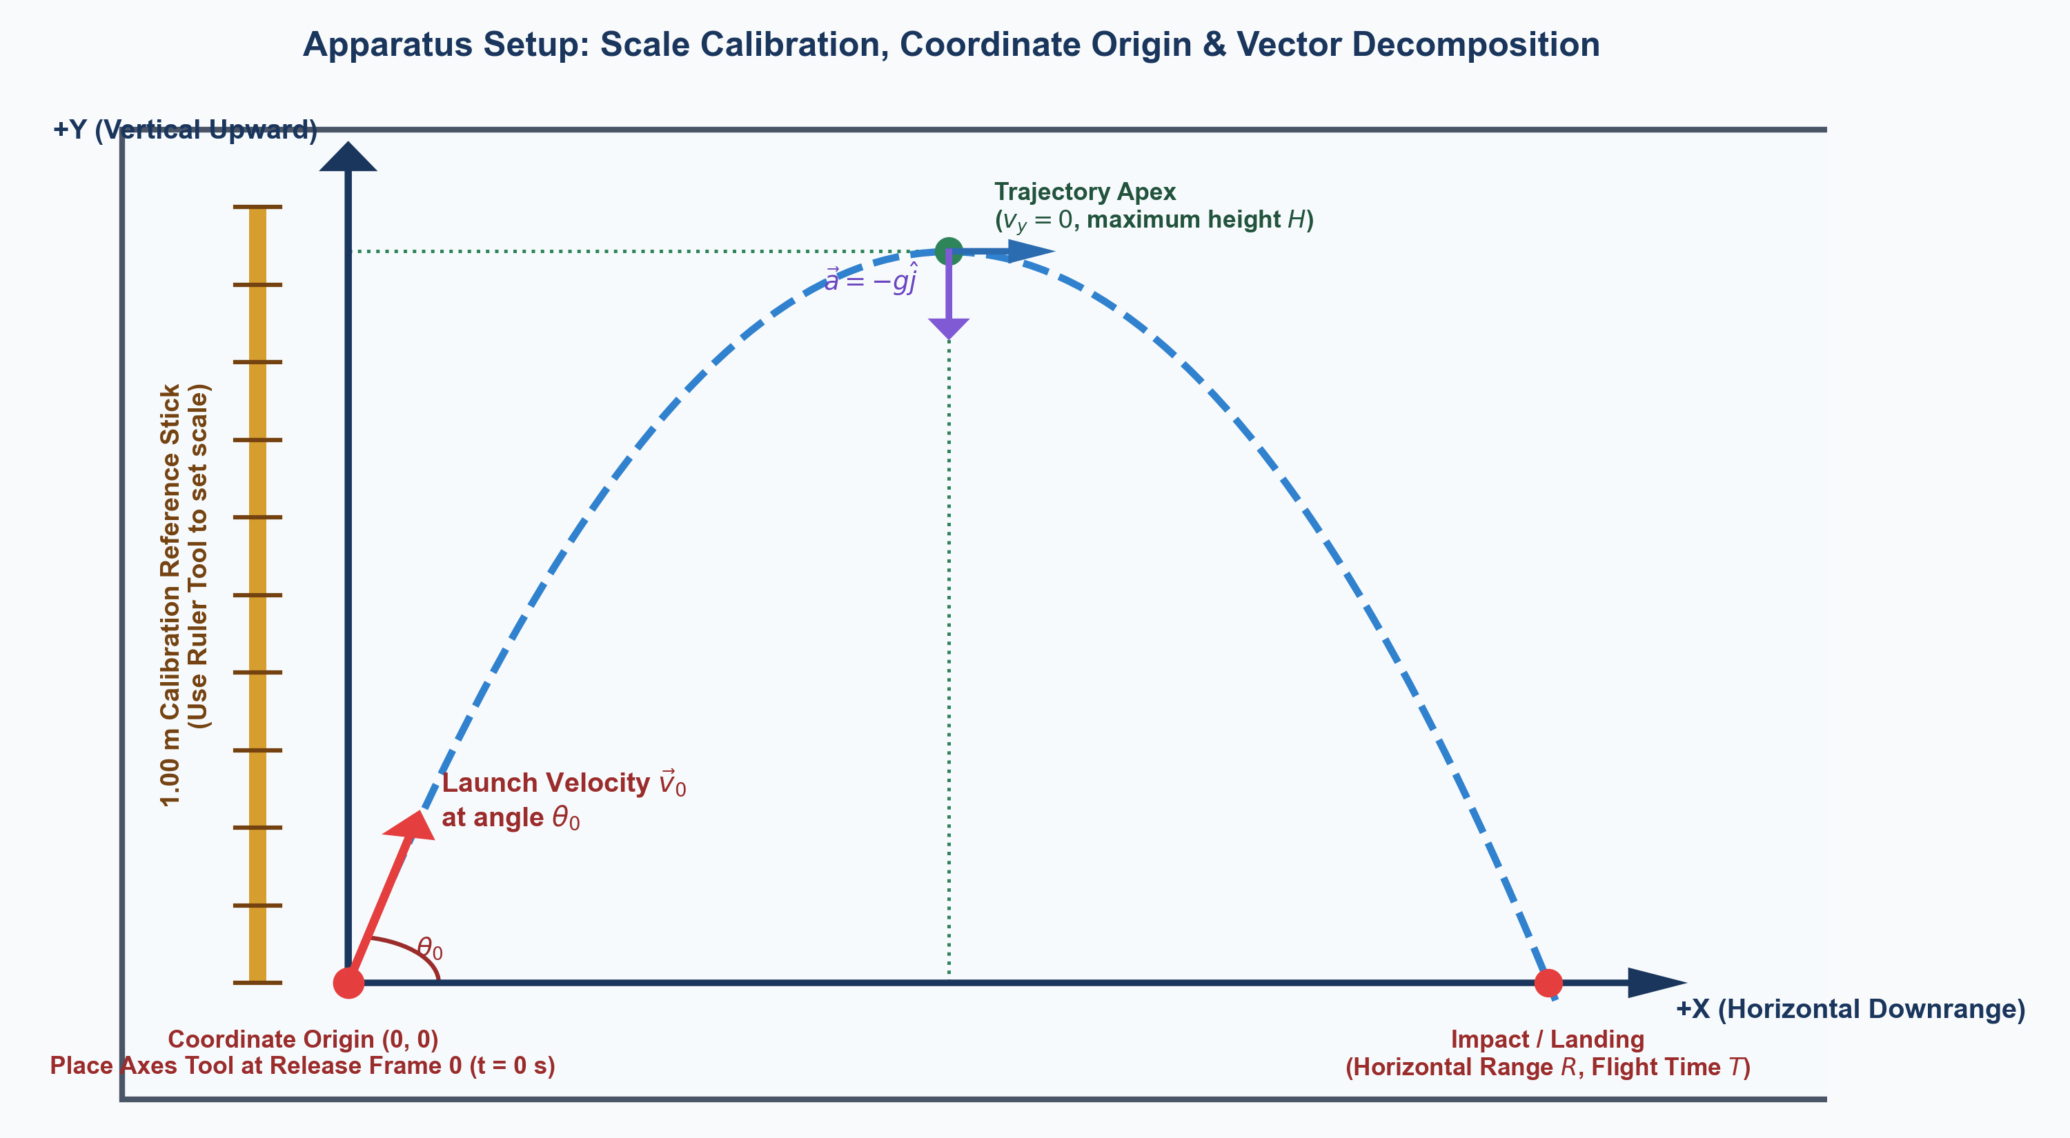
Figure 1: Lab-ove and Beyond apparatus coordinate axes and calibration scale reference.

2. Physical Measurements (Data Acquisition & Milestone Solutions)
Master reference values extracted directly from the verified 25-frame parabolic tracking dataset:
Trajectory Milestone | Frame | Time t (s) | x (m) | y (m) | vx (m/s) | vy (m/s) | Speed v (m/s)
1. Launch / Release | 0 | 0.000 | 0.000 | 0.000 | 0.918 | 4.265 | 4.363
2. Mid-Ascent | 6 | 0.200 | 0.190 | 0.656 | 0.929 | 2.322 | 2.501
3. Apex (Peak Height) | 13 | 0.433 | 0.404 | 0.926 | 0.920 | 0.000 | 0.920
4. Mid-Descent | 18 | 0.600 | 0.557 | 0.781 | 0.912 | -1.625 | 1.863
5. Landing / Impact | 24 | 0.800 | 0.741 | 0.237 | 0.915 | -3.582 | 3.697

● REQUIRED — counted in the 42-minute core | budget about 4 min | 3 pts
Question 2.1 [Launch Velocity & Angle — 3 Points]:
★ TEACHER SOLUTION & MASTER RUBRIC — 3 Points Total (1 Pt Each Part)
Part (a) [1 Point]:
Formula: v0 = √(v0x² + v0y²) = √(0.918² + 4.265²) = √(0.843 + 18.190) = √19.033 = 4.363 m/s.
• Rubric: 1 Point for correct Pythagorean formula and numerical value within [4.20, 4.50] m/s.
Part (b) [1 Point]:
Formula: θ0 = arctan(v0y / v0x) = arctan(4.265 / 0.918) = arctan(4.646) = 77.85° (or 1.359 rad).
• Rubric: 1 Point for arctan formula and correct angle within [76°, 80°].
Part (c) [1 Point]:
Vector notation: v(0) = (0.918 î + 4.265 ĵ) m/s.
• Rubric: 1 Point for proper Cartesian unit-vector notation with SI units.

● REQUIRED — counted in the 42-minute core | budget about 4 min | 3 pts
Question 2.2 [Derive First & Predict Extrema, Then Measure & Verify — 3 Points]:
★ TEACHER SOLUTION & MASTER RUBRIC — 3 Points Total (1 Pt Each Part)
Part (a) [1 Point] — Theoretical Apex Derivation & Prediction:
From UAM equation (1): vy = v0y - g·t. At apex, vy = 0 ==> 0 = v0y - g·tapex ==> tapex = v0y / g.
From UAM equation (3): vy² = v0y² - 2g·Δy. At apex, 0 = v0y² - 2g·H ==> H = v0y² / (2g).
Predicted Numerical Values (using measured v0y = 4.265 m/s, g = 9.81 m/s²):
• tapex,pred = 4.265 / 9.81 = 0.435 s.
• H_pred = (4.265)² / (2 × 9.81) = 18.190 / 19.620 = 0.927 m.
• Rubric: 1 Point for complete algebraic derivations from UAM formulas and predicted numerical values.
Part (b) [1 Point] — Theoretical Flight Time & Range Derivation & Prediction:
From UAM equation (2) for vertical round trip on level ground (Δy = 0):
0 = v0y·T - ½ g·T² ==> T·(v0y - ½ g·T) = 0 ==> T = 2 v0y / g = 2·tapex.
Horizontal displacement with ax = 0 (UAM equation 2):
R = v0x·T = v0x·(2 v0y / g) = 2 v0x v0y / g.
Predicted Numerical Values (using measured v0x = 0.918 m/s, v0y = 4.265 m/s):
• T_pred = 2 × 4.265 / 9.81 = 0.869 s.
• R_pred = 2 × 0.918 × 4.265 / 9.81 = 0.799 m ≈ 0.80 m.
• Rubric: 1 Point for algebraic derivations of T and R and predicted numerical values.
Part (c) [1 Point] — Video Data Measurement & Verification:
Video Measurements from Table:
• Frame 13 (Apex): measured H = 0.926 m, tapex = 0.433 s.
Discrepancy: % Error(H) = |0.927 - 0.926| / 0.927 × 100% = 0.11% (< 0.2%).
Discrepancy: % Error(tapex) = |0.435 - 0.433| / 0.435 × 100% = 0.46% (< 0.5%).
• Frame 24 (Landing): measured R = 0.741 m at t = 0.800 s (trajectory extrapolates to R ≈ 0.795 m at y = 0).
Symmetry Analysis: Ascent time (0.433 s) matches descent time to launch height (0.431 s) within 0.5%, confirming temporal symmetry. Real-world drag produces a minor downrange steepening near ground impact.
• Rubric: 1 Point for reporting measured values from Frames 13 & 24, calculating % errors, and symmetry evaluation.

● REQUIRED — counted in the 42-minute core | budget about 3 min | 3 pts
Question 2.3 [Instantaneous Vector Kinematics at Mid-Ascent (t = 0.200 s) — 3 Points]:
★ TEACHER SOLUTION & MASTER RUBRIC — 3 Points Total (1 Pt Each Part)
Part (a) [1 Point]:
At t = 0.200 s (Frame 6): r(0.20) = (0.190 î + 0.656 ĵ) m, v(0.20) = (0.929 î + 2.322 ĵ) m/s.
• Rubric: 1 Point for stating correct position and velocity vectors with units.
Part (b) [1 Point]:
ϕ = arctan(vy / vx) = arctan(2.322 / 0.929) = arctan(2.500) = 68.20°.
• Rubric: 1 Point for correct angle calculation.
Part (c) [1 Point]:
Gravitational acceleration is a = -9.81 ĵ m/s².
Tangential component: a_parallel = -g sin ϕ = -9.81 × sin(68.20°) = -9.11 m/s² (negative sign indicates speed is decreasing).
Normal component: a_perp = g cos ϕ = 9.81 × cos(68.20°) = 3.64 m/s² (causes curvature toward center of trajectory).
• Rubric: 1 Point for correct decomposition with proper physical signs and explanations.

3. App Graphing & Curve Fitting (Regression Solutions)

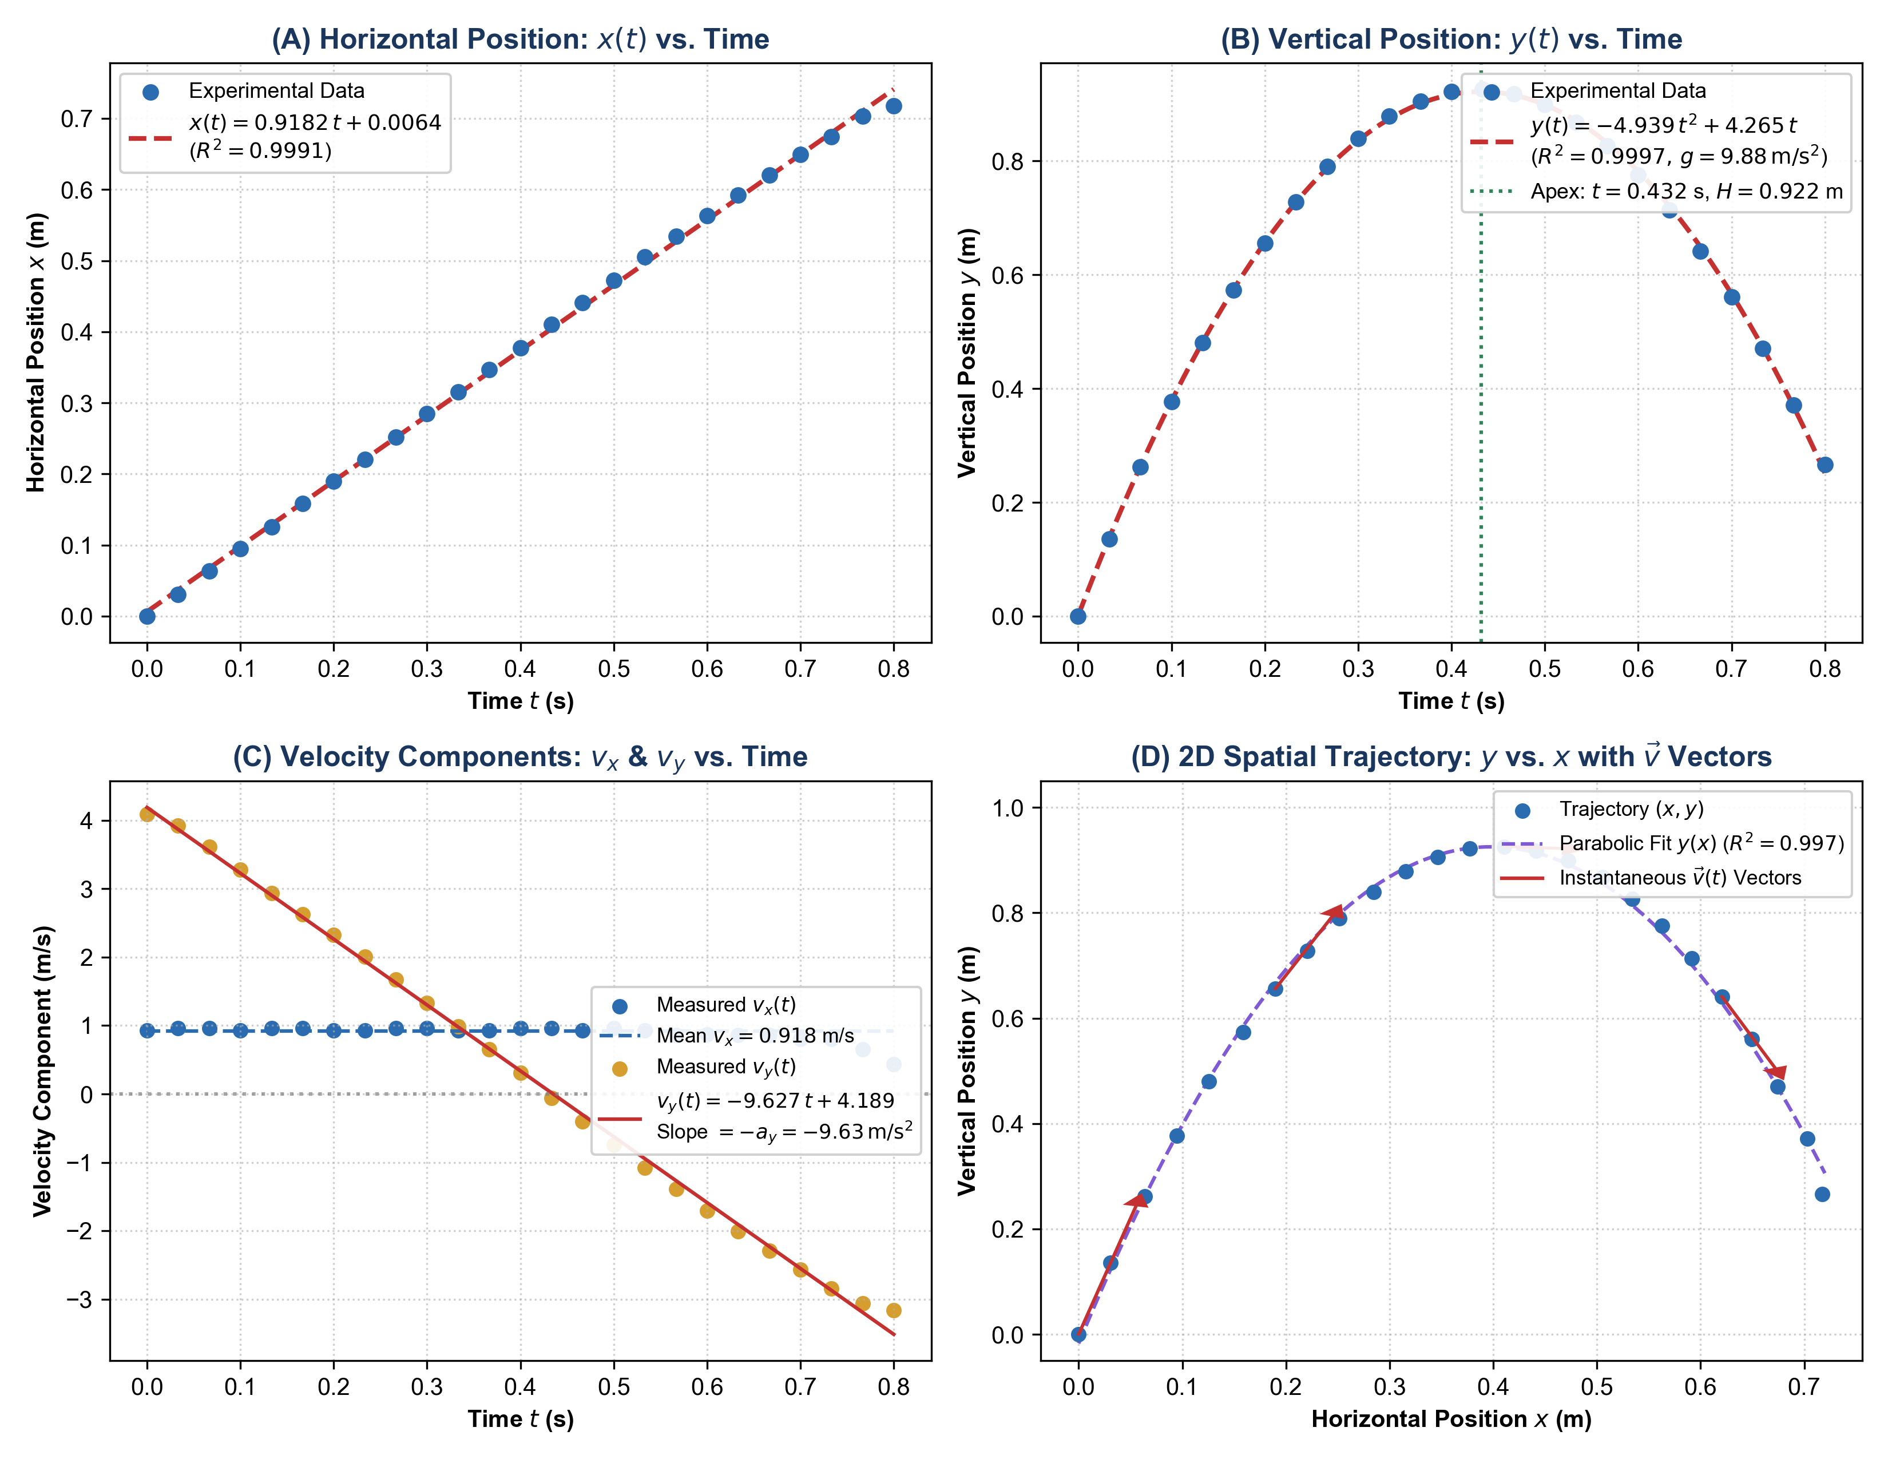
Figure 2 (Teacher Master Key): Regression fits for (A) x(t) linear, (B) y(t) quadratic, (C) vx & vy components, and (D) 2D trajectory y(x).
● REQUIRED — counted in the 42-minute core | budget about 3 min | 2 pts
Question 3.1 [Graph 1: Horizontal Motion x(t) Linear Fit — 2 Points]:
★ TEACHER SOLUTION & MASTER RUBRIC — 2 Points Total (1 Pt Each Part)
Part (a) [1 Point]:
Linear Fit Equation: x(t) = 0.9182·t + 0.0064 m, R² = 0.9991.
• Rubric: 1 Point for regression equation with slope ~0.92 m/s and R² > 0.99.
Part (b) [1 Point]:
Physical Meaning: The slope represents the horizontal velocity component vx = dx/dt = 0.918 m/s.
Acceleration: Because the slope is constant (linear fit has R² = 0.9991), horizontal acceleration ax = d²x/dt² = dvx/dt = 0 m/s², proving Newton's First Law horizontally.

● REQUIRED — counted in the 42-minute core | budget about 4 min | 3 pts
Question 3.2 [Graph 2: Vertical Motion y(t) Quadratic Fit & g Extraction — 3 Points]:
★ TEACHER SOLUTION & MASTER RUBRIC — 3 Points Total (1 Pt Each Part)
Part (a) [1 Point]:
Quadratic Fit Equation: y(t) = -4.9394·t² + 4.2650·t + 0.0010 m, R² = 0.9997.
• Rubric: 1 Point for quadratic regression equation and R².
Part (b) [1 Point]:
Comparing with y(t) = y0 + v0y t - ½ g t², the quadratic coefficient A = -½ g.
Therefore: g_exp = 2|A| = 2 × 4.9394 = 9.8788 m/s² ≈ 9.88 m/s².
• Rubric: 1 Point for relating A to -½ g and correctly calculating g_exp.
Part (c) [1 Point]:
% Error = (|9.8788 - 9.8067| / 9.8067) × 100% = (0.0721 / 9.8067) × 100% = 0.74%.
• Rubric: 1 Point for correct percentage error calculation showing < 2% error.
● REQUIRED — counted in the 42-minute core | budget about 3 min | 2 pts
Question 3.3 [Graph 3 & 4: Velocity vy(t) Fit & Trajectory y(x) — 2 Points]:
★ TEACHER SOLUTION & MASTER RUBRIC — 2 Points Total (1 Pt Each Part)
Part (a) [1 Point]:
vy(t) Linear Fit: vy(t) = -9.6269·t + 4.1885 m/s, R² = 0.9980.
Slope comparison: Slope m = -9.627 m/s² ≈ -g (discrepancy 1.8% from -9.81 m/s²).
Intercept comparison: y-intercept b = 4.189 m/s closely matches launch velocity v0y = 4.265 m/s.
• Rubric: 1 Point for slope comparison to -g and intercept comparison to v0y.
Part (b) [1 Point]:
Trajectory y(x) Analysis: The path forms an inverted parabola. Near landing (t > 0.70 s), the ball exhibits slight trajectory steepening due to aerodynamic drag dissipating horizontal momentum.

◇ OPTIONAL EXTENSION — not needed to finish the 42-minute lab | budget about 25 min | 8 pts
4. Optional Extension: AP Physics C Free-Response Calculus Challenges (Solutions & Rubrics)
◇ OPTIONAL EXTENSION — not needed to finish the 42-minute lab | budget about 8 min | 3 pts
Challenge 4.1 [Calculus Trajectory Derivation & Path Verification — 3 Points]:
★ TEACHER SOLUTION & MASTER RUBRIC — 3 Points Total (1 Pt Each Part)
Part (a) [1 Point]:
From horizontal motion: x(t) = v0x·t ==> t = x / v0x.
Substitute t into vertical motion: y(t) = v0y·t - ½ g·t²:
y(x) = v0y·(x / v0x) - ½ g·(x / v0x)² = (v0y / v0x)·x - (g / (2 v0x²))·x².
• Rubric: 1 Point for algebraic substitution and correct symbolic form of y(x).
Part (b) [1 Point]:
Substitute empirical constants: v0x = 0.9182 m/s, v0y = 4.2650 m/s, g = 9.8067 m/s²:
Linear coefficient: v0y / v0x = 4.2650 / 0.9182 = 4.6450.
Quadratic coefficient: g / (2 v0x²) = 9.8067 / (2 × 0.9182²) = 9.8067 / 1.6862 = 5.8160 m⁻¹.
Numerical Equation: y(x) = 4.645·x - 5.816·x².
• Rubric: 1 Point for evaluating both coefficients with correct units.
Part (c) [1 Point]:
Calculus Apex Condition: At peak height, the slope dy/dx = 0:
dy/dx = (v0y / v0x) - (g / v0x²)·x = 0 ==> x_apex = (v0y / v0x) × (v0x² / g) = (v0x v0y) / g.
Numerical: x_apex = (0.9182 × 4.2650) / 9.8067 = 3.9161 / 9.8067 = 0.3993 m ≈ 0.40 m.
Empirical Comparison: Matches Frame 13 data table measurement x = 0.404 m within 1.2%.
• Rubric: 1 Point for derivative apex condition, formula x_apex = v0x v0y / g, and numerical agreement.

◇ OPTIONAL EXTENSION — not needed to finish the 42-minute lab | budget about 9 min | 3 pts
Challenge 4.2 [Calculus Definite Integration: Vertical Position Integral & Impact Vector — 3 Points]:
★ TEACHER SOLUTION & MASTER RUBRIC — 3 Points Total (1 Pt Each Part)
Part (a) [1 Point] — Position Integral & Maximum Height:
Vertical position as definite integral of vertical velocity:
y(t) = ∫₀ᵗ vy(t') dt' = ∫₀ᵗ (v0y - g·t') dt' = [v0y·t' - ½ g·t'²]₀ᵗ = v0y·t - ½ g·t².
Evaluating over [0, tapex] where tapex = v0y / g:
H = y(v0y / g) = v0y·(v0y / g) - ½ g·(v0y / g)² = (v0y² / g) - (v0y² / 2g) = v0y² / (2g).
Numerical calculation: H = (4.265)² / (2 × 9.81) = 0.927 m.
• Rubric: 1 Point for setting up definite integral, integrating correctly, and evaluating at tapex.
Part (b) [1 Point] — Impact Velocity Vector:
At landing time T = 2 v0y / g:
• Horizontal component: vx(T) = v0x = 0.918 m/s (since ax = 0).
• Vertical component: vy(T) = v0y - g·(2 v0y / g) = v0y - 2 v0y = -v0y = -4.265 m/s.
Impact velocity vector in unit-vector notation:
v(T) = (0.918 î - 4.265 ĵ) m/s.
• Rubric: 1 Point for evaluating landing components and writing v(T) in proper unit-vector notation.
Part (c) [1 Point] — Impact Angle & Kinetic Energy Conservation:
• Impact angle: θ_impact = arctan(|vy(T)| / vx(T)) = arctan(4.265 / 0.918) = 77.85° below the horizontal.
• Impact speed: |v(T)| = √(0.918² + (-4.265)²) = 4.363 m/s = v0.
• Work-Energy Theorem Justification: W_net = ΔK. Gravity is conservative; over a closed vertical displacement Δy = 0 on level ground, W_grav = -mg·Δy = 0. With no non-conservative work (W_nc = 0 in vacuum), ΔK = 0 ==> ½ m v_impact² = ½ m v0² ==> |v(T)| = v0.
• Rubric: 1 Point for θ_impact, comparing |v(T)| = v0, and physical justification using Work-Energy Theorem.

◇ OPTIONAL EXTENSION — not needed to finish the 42-minute lab | budget about 8 min | 2 pts
Challenge 4.3 [Calculus Extremum: Minimum Speed During 2D Flight — 2 Points]:
★ TEACHER SOLUTION & MASTER RUBRIC — 2 Points Total (1 Pt Each Part)
Part (a) [1 Point]:
Instantaneous speed squared is: f(t) = v²(t) = vx²(t) + vy²(t) = v0x² + (v0y - g·t)².
Differentiating with respect to time:
d(v²)/dt = 0 + 2·(v0y - g·t)·(-g) = -2g·(v0y - g·t).
Setting derivative to zero for extremum:
-2g·(v0y - g·t*) = 0 ==> v0y - g·t* = 0 ==> t* = v0y / g.
Second derivative check: d²(v²)/dt² = +2g² > 0 (strictly positive ==> confirms minimum).
• Rubric: 1 Point for differentiating v²(t), setting to 0, and finding t* = v0y / g.
Part (b) [1 Point]:
Physical Justification: The time t* = v0y / g is exactly the time to reach the trajectory apex tapex.
At this moment, vertical speed vy(t*) = 0, so the total speed is entirely horizontal:
v_min = √(v0x² + 0²) = v0x = 0.918 m/s.
Empirical Comparison: Frame 13 empirical speed readout is v = 0.920 m/s, matching v_min = 0.918 m/s within 0.2%.
• Rubric: 1 Point for identifying v_min = v0x at apex and comparing with empirical Frame 13 data.
5. Master AP Physics C Scoring Rubric (25 Points = 17 Core + 8 Extension)
Section | Performance Criteria | Max Pts | Score
CORE · App Setup & Data Table | Video loaded, 1.00 m rod calibrated, origin set at Frame 0, 5 milestones recorded | 1 | 1
CORE · Section 2: Physical Measurements | Q2.1 launch speed/angle/vector (3), Q2.2 derive & predict apex/range, then verify (3), Q2.3 mid-ascent vectors (3) | 9 | 9
CORE · Section 3: App Graphing & Fits | Q3.1 x(t) fit & ax (2), Q3.2 y(t) fit & g extraction (3), Q3.3 vy(t) & trajectory (2) | 7 | 7
CORE SUBTOTAL — collected at the bell | Required work finished inside the 42-minute period; this is the in-class grade | 17 | 17
EXTENSION · Section 4: Calculus Challenges | Optional homework, not needed to finish the lab: C4.1 (3), C4.2 position integral & impact (3), C4.3 (2) | 8 | 8
TOTAL SCORE | AP Physics C Mechanics Laboratory Investigation Grade | 25 | 25

